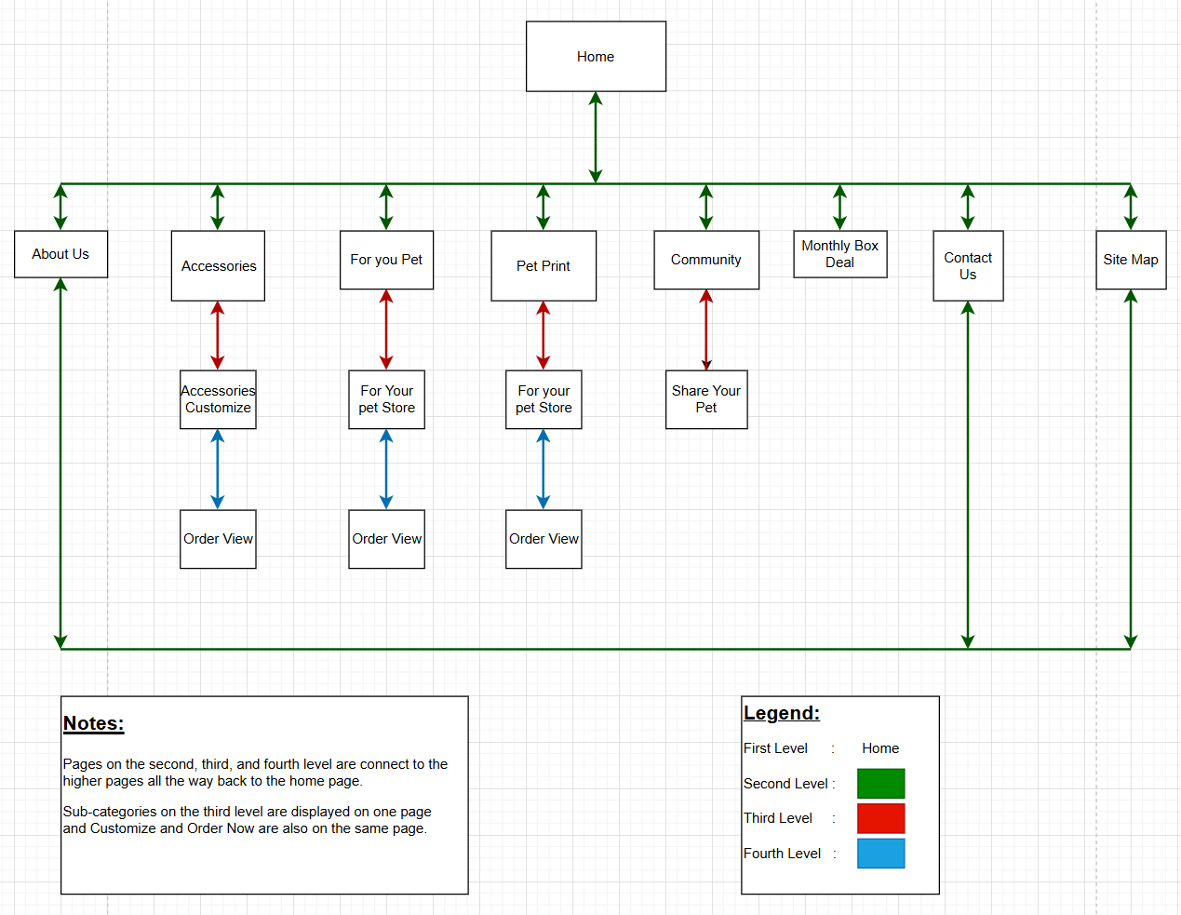
Pet Print
Store

Storyboard Template for Multimedia Product Development
Client Name: Pet Paradise
Project Title: Company Website
Last Update: 10/09/2025 |  | Name of Designer: Kevin Caudell
Panel/Page ID: index.html |  | Panel/Page/Frame No: Home Page (Desktop)
Description of Copy text: | Text: Welcome to Pet Paradise, where we make your pet feel special!  Text Style: ‘Arial, Helvetica, sans-serif’, Font Size: 15, Font Color: Dark Grey, Font Decoration: underlined.  Page Heading: Pet Paradise  Page Heading Style: Font: ‘Arial, Helvetica, sans-serif’, Font Size: 24, Font Color: Dark Grey, Font Decoration: underlined.
User Interactions: | There is a navigation bar at the top of each webpage on every level of the website. The navigation is always going to be displayed, allowing the customer to navigate to anywhere on the website from any page. The logo at the top left also is a link, linking back to the homepage.
Hyper Links: | index.html  aboutus.html  accessories.html  foryourpet.html  petprint.html  community.html  monthlyboxdeal.html  contactus.html  sitemap.html
Audio inclusion and controls: | None
Video inclusion and controls: | None
Color specifications: | Page Background: light orange, fff9f2  Header: (orange, ffa94d, background), (pastel azure, 66ccff, branding name), (light orange, fff9f2, branding name border), (dark grey, 333333, text)  Navigation Bar: (light orange, fff9f2, text borders), (pastel azure, 66ccff, buttons), (green, 32cd32, rollover buttons), (orange, ffa94d, background), (dark grey, 333333, text links).  Body: (orange, ffa94d), (pastel azure, 66ccff), (light orange, fff9f2, borders), (dark grey, 333333, text).
Panel Layout
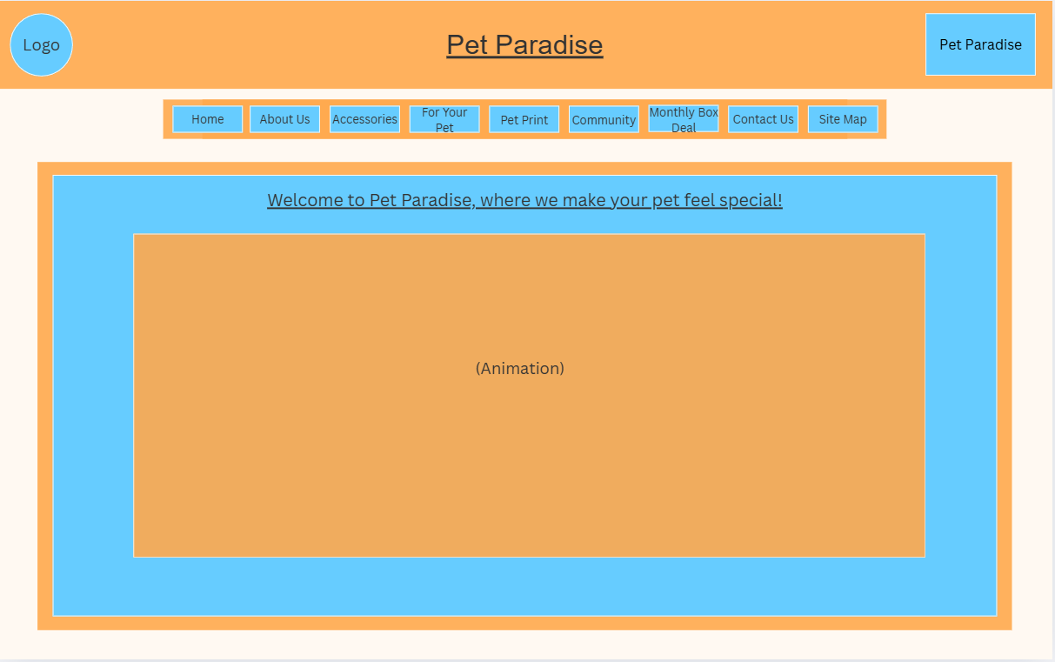

Storyboard Template for Multimedia Product Development
Client Name: Pet Paradise
Project Title: Company Website
Last Update: 10/09/2025 |  | Name of Designer: Kevin Caudell
Panel/Page ID: index.html |  | Panel/Page/Frame No: Home Page (Tablet)
Description of Copy text: | Text: Welcome to Pet Paradise, where we make your pet feel special!  Text Font: ‘Arial, Helvetica, sans-serif’, Font Size: 15, Font Color: Dark Grey, Font Decoration: underlined.  Page Heading: Font: ‘Arial, Helvetica, sans-serif’, Font Size: 24, Font Color: Dark Grey, Font Decoration: underlined.
User Interactions: | There is navigation buttons on the left of each page at every level, allowing the customer to navigate to any part of the website. The company logo at the top left is a hyperlink, linking back to the homepage.
Hyper Links: | index.html  aboutus.html  accessories.html  foryourpet.html  petprint.html  community.html  monthlyboxdeal.html  contactus.html  sitemap.html
Audio inclusion and controls: | None
Video inclusion and controls: | None
Color specifications: | Page Background: light orange, fff9f2  Header: (orange, ffa94d, background), (pastel azure, 66ccff, branding name), (light orange, fff9f2, branding name border), (dark grey, 333333, text)  Navigation Bar: (light orange, fff9f2, text borders), (pastel azure, 66ccff, buttons), (green, 32cd32, rollover buttons), (orange, ffa94d, background), (dark grey, 333333, text links).  Body: (orange, ffa94d), (pastel azure, 66ccff), (light orange, fff9f2, borders), (dark grey, 333333, text).
Panel Layout
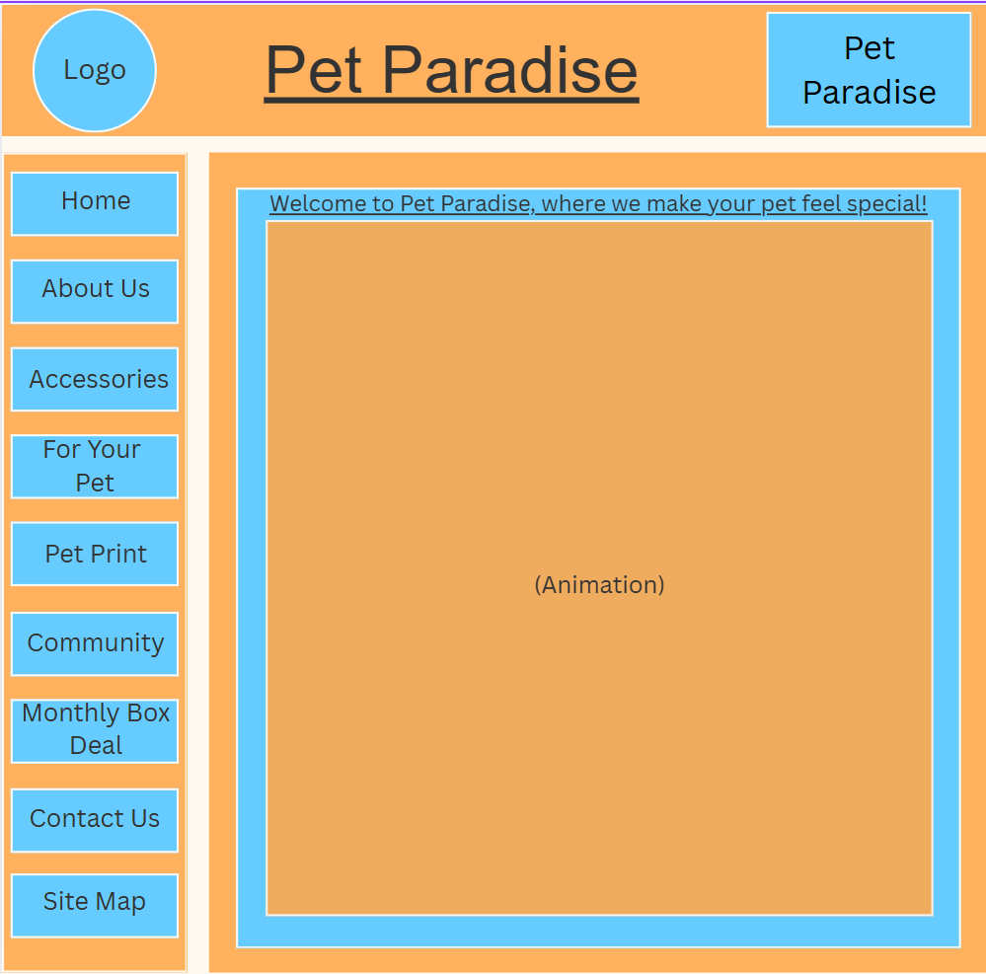

Storyboard Template for Multimedia Product Development
Client Name: Pet Paradise
Project Title: Company Website
Last Update: 10/09/2025 |  | Name of Designer: Kevin Caudell
Panel/Page ID: index.html |  | Panel/Page/Frame No: Home Page (Mobile)
Description of Copy text: | Text: Welcome to Pet Paradise, where we make your pet feel special!  Text Font: ‘Arial, Helvetica, sans-serif’, Font Size: 7, Font Color: Dark Grey, Font Decoration: underlined.  Page Heading: Font: ‘Arial, Helvetica, sans-serif’, Font Size: 16, Font Color: Dark Grey, Font Decoration: underlined.
User Interactions: | The navigation on each webpage collapses into a hamburger icon, that when clicked brings a dropdown menu with all the hyperlinks, linking to all webpages. The company logo in the top left is a hyperlink, linking back to the homepage.
Hyper Links: | index.html  aboutus.html  accessories.html  foryourpet.html  petprint.html  community.html  monthlyboxdeal.html  contactus.html  sitemap.html
Audio inclusion and controls: | None
Video inclusion and controls: | None
Color specifications: | Page Background: light orange, fff9f2  Header: (orange, ffa94d, background), (pastel azure, 66ccff, branding name), (light orange, fff9f2, branding name border), (dark grey, 333333, text)  Navigation Bar: (light orange, fff9f2, text borders), (pastel azure, 66ccff, buttons), (green, 32cd32, rollover buttons), (orange, ffa94d, background), (dark grey, 333333, text links).  Body: (orange, ffa94d), (pastel azure, 66ccff), (light orange, fff9f2, borders), (dark grey, 333333, text).
Panel Layout
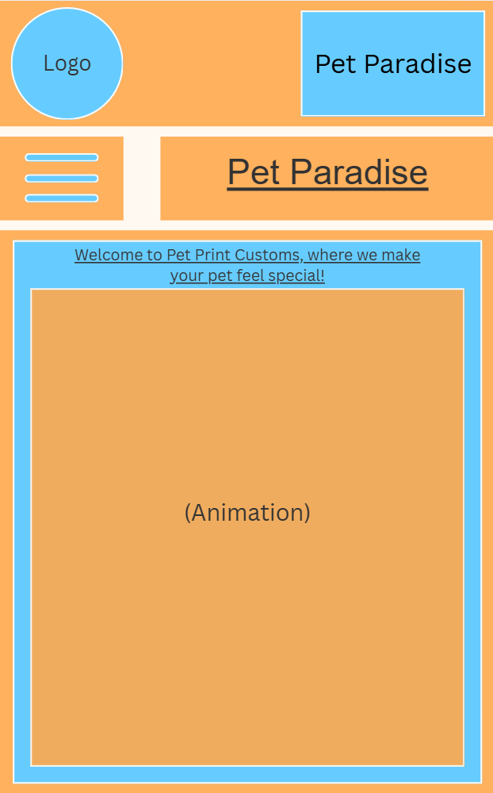

Storyboard Template for Multimedia Product Development
Client Name: Pet Paradise
Project Title: Company Website
Last Update: 10/09/2025 |  | Name of Designer: Kevin Caudell
Panel/Page ID: aboutus.html |  | Panel/Page/Frame No: About Us
Description of Copy text: | Text: About Pet Paradise  Text Font: ‘Arial, Helvetica, sans-serif’, Font Size: 19, Font Color: Dark Grey.  Page Heading: About Us  Page Heading Style: Font: ‘Arial, Helvetica, sans-serif’, Font Size: 24, Font Color: Dark Grey, Font Decoration: underlined  Description Text Style: Font: ‘Arial, Helvetica, sans-serif’, Font Size: 13, Font Color: Dark Grey.
User Interactions: | There is a navigation bar at the top of each webpage on every level of the website. The navigation is always going to be displayed, allowing the customer to navigate to anywhere on the website from any page. The logo at the top left also is a link, linking back to the homepage.
Hyper Links: | index.html  aboutus.html  accessories.html  foryourpet.html  petprint.html  community.html  monthlyboxdeal.html  contactus.html  sitemap.html
Audio inclusion and controls: | None
Video inclusion and controls: | None
Color specifications: | Page Background: light orange, fff9f2  Header: (orange, ffa94d, background), (pastel azure, 66ccff, branding name), (light orange, fff9f2, branding name border), (dark grey, 333333, text)  Navigation Bar: (light orange, fff9f2, text borders), (pastel azure, 66ccff, buttons), (green, 32cd32, rollover buttons), (orange, ffa94d, background), (dark grey, 333333, text links).  Body: (orange, ffa94d), (dark grey, 333333, text).
Panel Layout
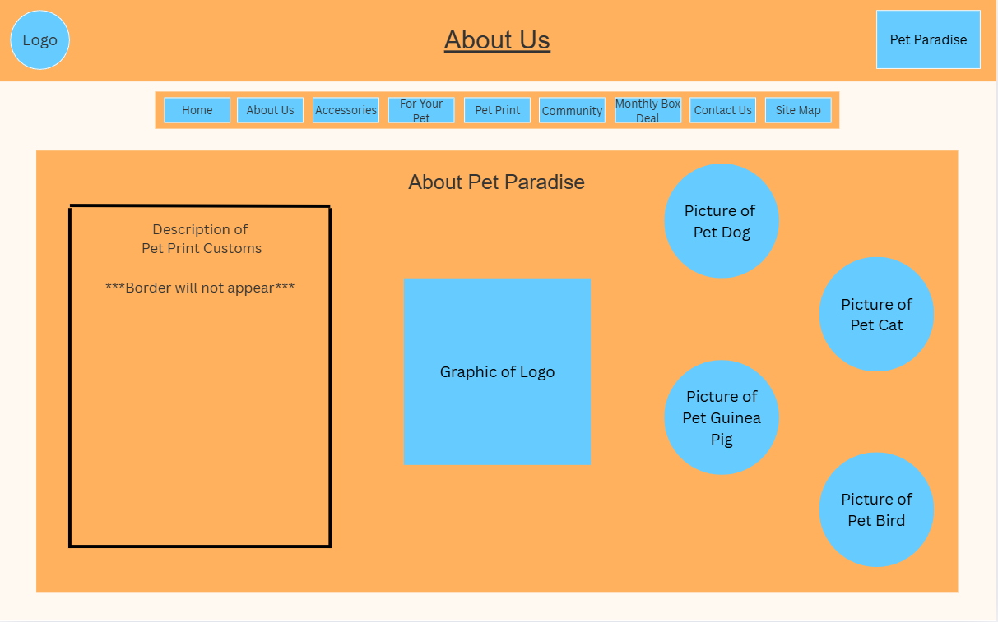

Storyboard Template for Multimedia Product Development
Client Name: Pet Paradise
Project Title: Company Website
Last Update: 10/09/2025 |  | Name of Designer: Kevin Caudell
Panel/Page ID: accessories.html |  | Panel/Page/Frame No: Accessories
Description of Copy text: | Sub Headers: Collar, Leash, Harness  Sub Header Style: Font: ‘Arial, Helvetica, sans-serif’, Font Size: 14, Font Color: Dark Grey  Page Heading: Accessories  Page Heading Style: Font: ‘Arial, Helvetica, sans-serif’, Font Size: 24, Font Color: Dark Grey, Font Decoration: underlined  Customize Link: CUSTOMIZE  Customize Link Style: Font: ‘Arial, Helvetica, sans-serif’, Font Size: 14, Font Color: Dark Grey, Font Decoration: BOLD
User Interactions: | There is a navigation bar at the top of each webpage on every level of the website. The navigation is always going to be displayed, allowing the customer to navigate to anywhere on the website from any page. The logo at the top left also is a link, linking back to the homepage.  There are also “customize” links under each product that link to the same webpage.
Hyper Links: | index.html  aboutus.html  accessories.html  foryourpet.html  petprint.html  community.html  monthlyboxdeal.html  contactus.html  sitemap.html  customaccessories.html
Audio inclusion and controls: | None
Video inclusion and controls: | None
Color specifications: | Page Background: light orange, fff9f2  Header: (orange, ffa94d, background), (pastel azure, 66ccff, branding name), (light orange, fff9f2, branding name border), (dark grey, 333333, text)  Navigation Bar: (light orange, fff9f2, text borders), (pastel azure, 66ccff, buttons), (green, 32cd32, rollover buttons), (orange, ffa94d, background), (dark grey, 333333, text links).  Body: (orange, ffa94d, cards), (pastel azure, 66ccff, sub headers), (light orange, fff9f2, sub header borders), (dark grey, 333333, text) (green, 32cd32, Customize button).
Panel Layout
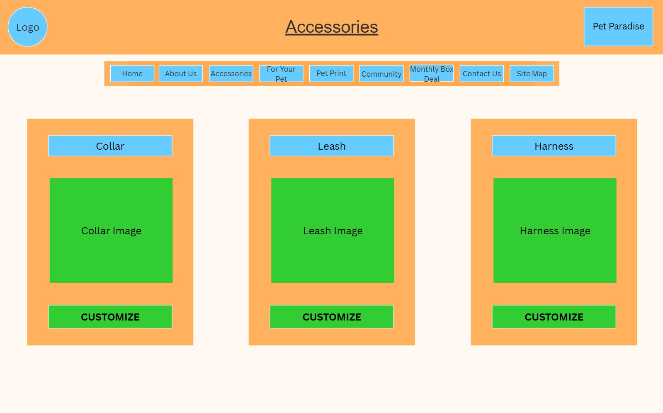

Storyboard Template for Multimedia Product Development
Client Name: Pet Paradise
Project Title: Company Website
Last Update: 10/09/2025 |  | Name of Designer: Kevin Caudell
Panel/Page ID: foryourpet.html |  | Panel/Page/Frame No: For Your Pet
Description of Copy text: | Sub Header: Toys, Furniture  Sub Header Style: Font: ‘Arial, Helvetica, sans-serif’, Font Size: 14, Font Color: Dark Grey  Page Heading: For Your Pet  Page Heading Style: Font: ‘Arial, Helvetica, sans-serif’, Font Size: 24, Font Color: Dark Grey, Font Decoration: underlined  Customize Link: CUSTOMIZE  Customize Link Style: Font: ‘Arial, Helvetica, sans-serif’, Font Size: 14, Font Color: Dark Grey, Font Decoration: BOLD
User Interactions: | There is a navigation bar at the top of each webpage on every level of the website. The navigation is always going to be displayed, allowing the customer to navigate to anywhere on the website from any page. The logo at the top left also is a link, linking back to the homepage.  There are also “customize” links under each product that link to the same webpage.
Hyper Links: | index.html  aboutus.html  accessories.html  foryourpet.html  petprint.html  community.html  monthlyboxdeal.html  contactus.html  sitemap.html  foryourpetstore.html
Audio inclusion and controls: | None
Video inclusion and controls: | None
Color specifications: | Page Background: light orange, fff9f2  Header: (orange, ffa94d, background), (pastel azure, 66ccff, branding name), (light orange, fff9f2, branding name border), (dark grey, 333333, text)  Navigation Bar: (light orange, fff9f2, text borders), (pastel azure, 66ccff, buttons), (green, 32cd32, rollover buttons), (orange, ffa94d, background), (dark grey, 333333, text links).  Body: (orange, ffa94d, cards), (pastel azure, 66ccff, sub headers), (light orange, fff9f2, sub header borders), (dark grey, 333333, text) (green, 32cd32, Customize button).
Panel Layout
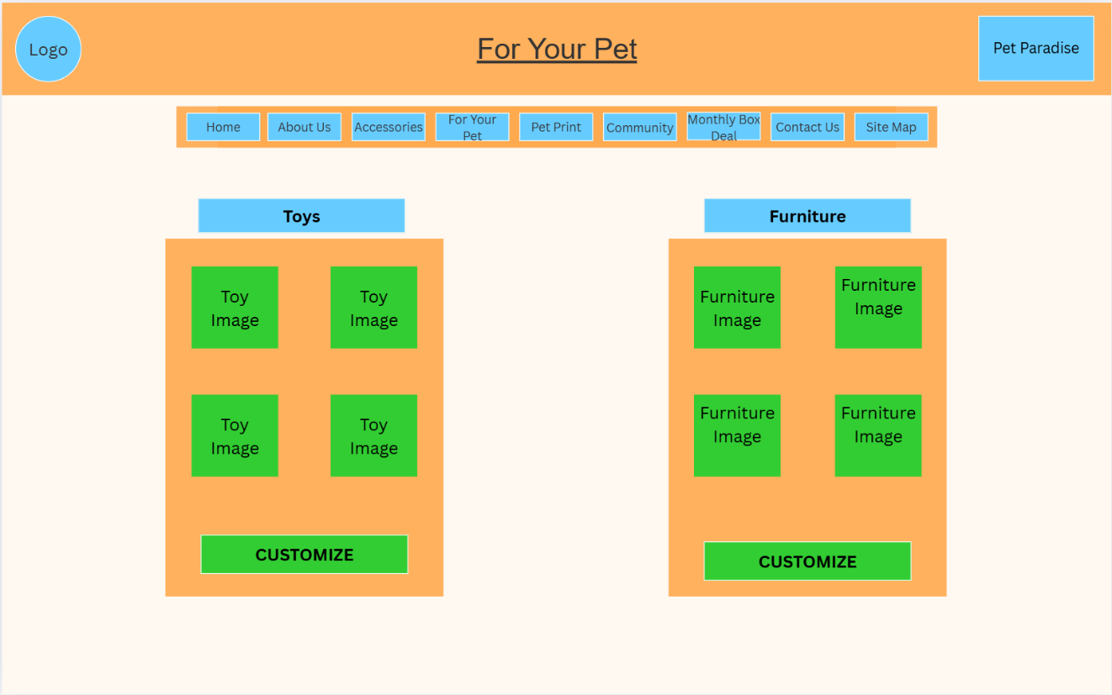

Storyboard Template for Multimedia Product Development
Client Name: Pet Paradise
Project Title: Company Website
Last Update: 10/09/2025 |  | Name of Designer: Kevin Caudell
Panel/Page ID: petprint.html |  | Panel/Page/Frame No: Pet Print
Description of Copy text: | Sub Header: Picture Frames, Magnet, Shirt  Sub Header Style: Font: ‘Arial, Helvetica, sans-serif’, Font Size: 14, Font Color: Dark Grey  Page Heading: Pet Prints  Page Heading Style: Font: ‘Arial, Helvetica, sans-serif’, Font Size: 24, Font Color: Dark Grey, Font Decoration: underlined  Customize Link: CUSTOMIZE  Customize Link Style: Font: ‘Arial, Helvetica, sans-serif’, Font Size: 14, Font Color: Dark Grey, Font Decoration: BOLD
User Interactions: | There is a navigation bar at the top of each webpage on every level of the website. The navigation is always going to be displayed, allowing the customer to navigate to anywhere on the website from any page. The logo at the top left also is a link, linking back to the homepage.  There are also “customize” links under each product that link to the same webpage.
Hyper Links: | index.html  aboutus.html  accessories.html  foryourpet.html  petprint.html  community.html  monthlyboxdeal.html  contactus.html  sitemap.html  petprintstore.html
Audio inclusion and controls: | None
Video inclusion and controls: | None
Color specifications: | Page Background: light orange, fff9f2  Header: (orange, ffa94d, background), (pastel azure, 66ccff, branding name), (light orange, fff9f2, branding name border), (dark grey, 333333, text)  Navigation Bar: (light orange, fff9f2, text borders), (pastel azure, 66ccff, buttons), (green, 32cd32, rollover buttons), (orange, ffa94d, background), (dark grey, 333333, text links).  Body: (orange, ffa94d, cards), (pastel azure, 66ccff, sub headers), (light orange, fff9f2, sub header borders), (dark grey, 333333, text) (green, 32cd32, Customize button).
Panel Layout
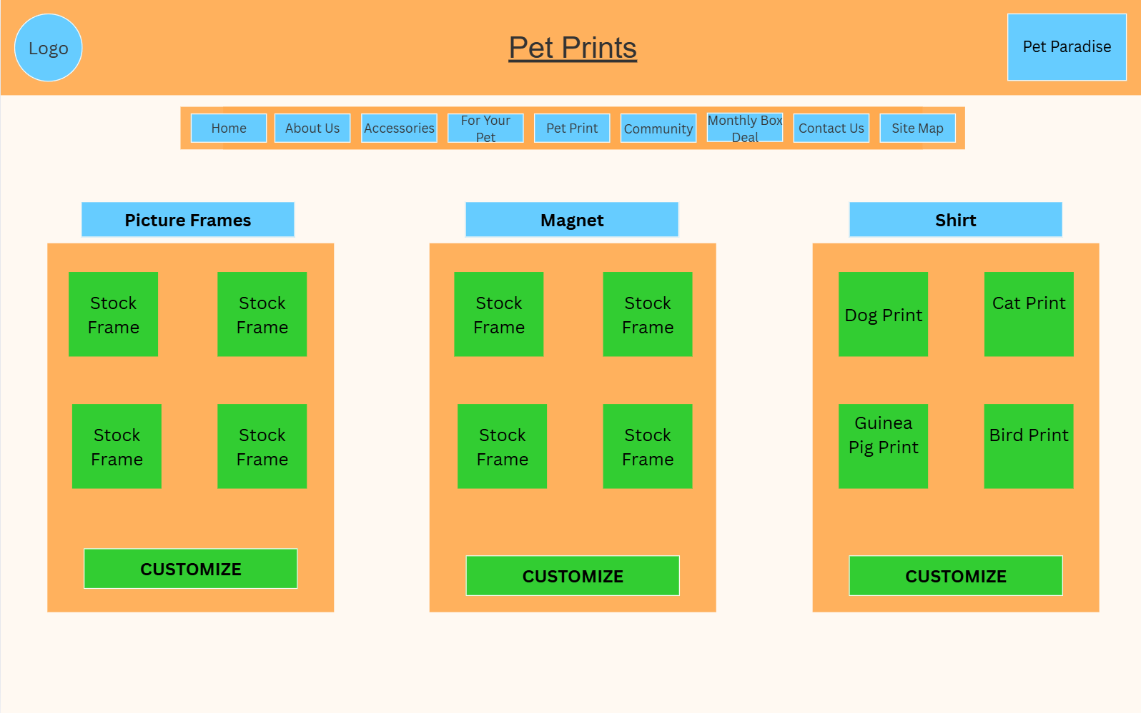

Storyboard Template for Multimedia Product Development
Client Name: Pet Paradise
Project Title: Company Website
Last Update: 10/09/2025 |  | Name of Designer: Kevin Caudell
Panel/Page ID: community.html |  | Panel/Page/Frame No: Community
Description of Copy text: | Page Heading: Community  Page Heading Style: Font: ‘Arial, Helvetica, sans-serif’, Font Size: 24, Font Color: Dark Grey, Font Decoration: underlined  Share Your Pet Button: Share Your Pet  Share Your Pet Button Style: Font: ‘Arial, Helvetica, sans-serif’, Font Size: 14, Font Color: Dark Grey  Body: Name of person posting, comments that they input.  Body Style: Font: ‘Arial, Helvetica, sans-serif’, Font Size: 14, Font Color: Dark Grey
User Interactions: | There is a navigation bar at the top of each webpage on every level of the website. The navigation is always going to be displayed, allowing the customer to navigate to anywhere on the website from any page. The logo at the top left also is a link, linking back to the homepage.  There is a button “Share your Pet” which is linked to a webpage allowing you to post about your pet.
Hyper Links: | index.html  aboutus.html  accessories.html  foryourpet.html  petprint.html  community.html  monthlyboxdeal.html  contactus.html  sitemap.html  shareyourpet.html
Audio inclusion and controls: | None
Video inclusion and controls: | None
Color specifications: | Page Background: light orange, fff9f2  Header: (orange, ffa94d, background), (pastel azure, 66ccff, branding name), (light orange, fff9f2, branding name border), (dark grey, 333333, text)  Navigation Bar: (light orange, fff9f2, text borders), (pastel azure, 66ccff, buttons), (green, 32cd32, rollover buttons), (orange, ffa94d, background), (dark grey, 333333, text links).  Body: (orange, ffa94d, comment box, (light orange, fff9f2, sub image borders), (dark grey, 333333, text) (green, 32cd32, Share Your Pet Link).
Panel Layout
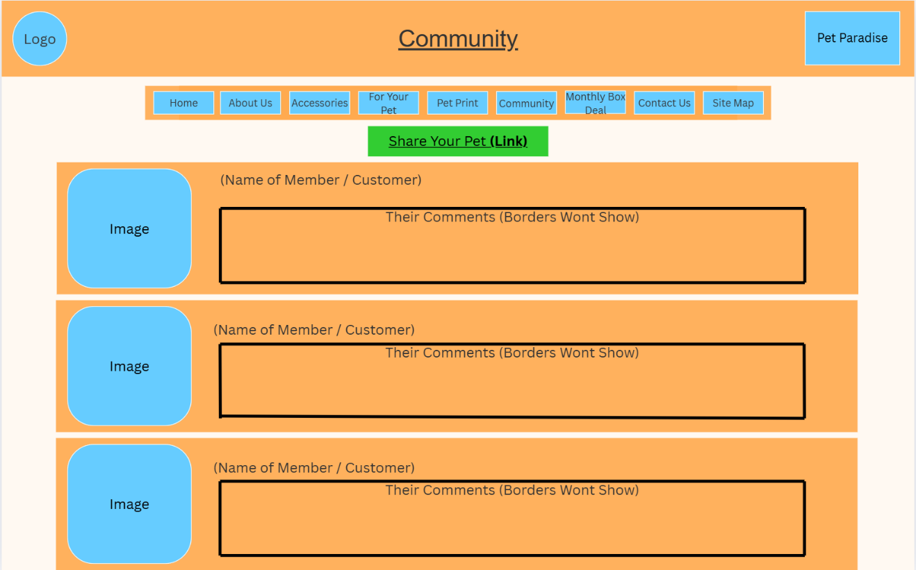

Storyboard Template for Multimedia Product Development
Client Name: Pet Paradise
Project Title: Company Website
Last Update: 10/09/2025 |  | Name of Designer: Kevin Caudell
Panel/Page ID: monthlyboxdeal.html |  | Panel/Page/Frame No: Monthly Box Deal
Description of Copy text: | Page Heading: Monthly Box Deal  Page Heading Style: Font: ‘Arial, Helvetica, sans-serif’, Font Size: 24, Font Color: Dark Grey, Font Decoration: underlined  Sub Header: Month Name + Box  Sub Header Style: Font: ‘Arial, Helvetica, sans-serif’, Font Size: 14, Font Color: Dark Grey.  Body: Price  Body Style: Font: ‘Arial, Helvetica, sans-serif’, Font Size: 14, Font Color: Dark Grey  Order Now: ORDER NOW  Order Now Style: Font: ‘Arial, Helvetica, sans-serif’, Font Size: 16, Font Color: Dark Grey, Font Decoration: BOLD
User Interactions: | There is a navigation bar at the top of each webpage on every level of the website. The navigation is always going to be displayed, allowing the customer to navigate to anywhere on the website from any page. The logo at the top left also is a link, linking back to the homepage.
Hyper Links: | index.html  aboutus.html  accessories.html  foryourpet.html  petprint.html  community.html  monthlyboxdeal.html  contactus.html  sitemap.html
Audio inclusion and controls: | None
Video inclusion and controls: | None
Color specifications: | Page Background: light orange, fff9f2  Header: (orange, ffa94d, background), (pastel azure, 66ccff, branding name), (light orange, fff9f2, branding name border), (dark grey, 333333, text)  Navigation Bar: (light orange, fff9f2, text borders), (pastel azure, 66ccff, buttons), (green, 32cd32, rollover buttons), (orange, ffa94d, background), (dark grey, 333333, text links).  Body: (dark grey, 333333, text) (green, 32cd32, Order Now button).
Panel Layout
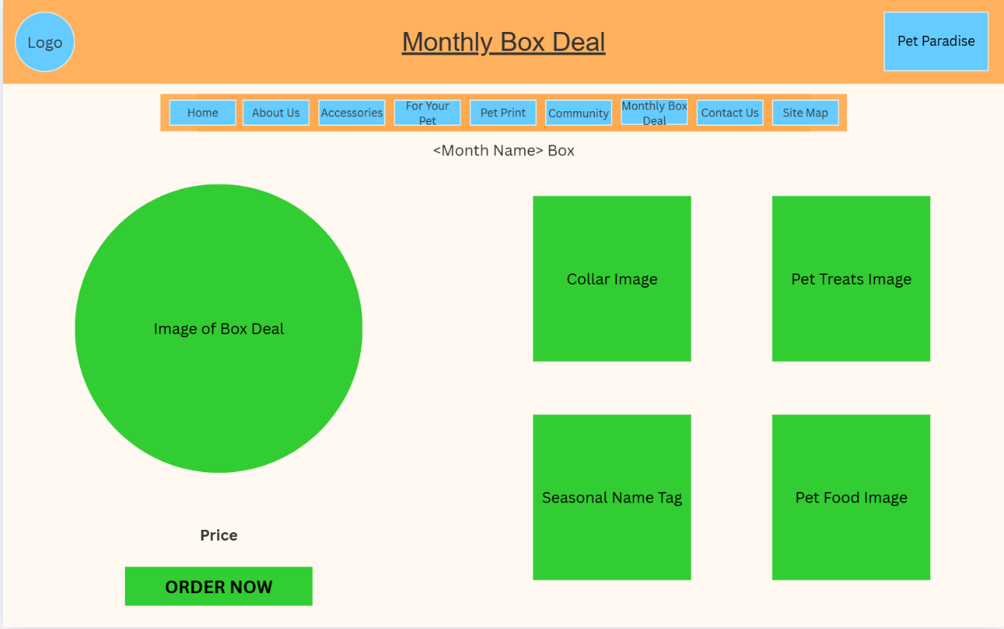

Storyboard Template for Multimedia Product Development
Client Name: Pet Paradise
Project Title: Company Website
Last Update: 10/09/2025 |  | Name of Designer: Kevin Caudell
Panel/Page ID: contactus.html |  | Panel/Page/Frame No: Contact Us
Description of Copy text: | Page Heading: Contact Us  Page Heading Style: Font: ‘Arial, Helvetica, sans-serif’, Font Size: 24, Font Color: Dark Grey, Font Decoration: underlined  Body: Name and Title of Employee and Description of employee  Body Style: Font: ‘Arial, Helvetica, sans-serif’, Font Size: 14, Font Color: Dark Grey  Emails: Ex. Jadams2@gmail.com  Emails style: Font: ‘Arial, Helvetica, sans-serif’, Font Size: 14, Font Color: Pastel Azure, Font Decoration: Underlined
User Interactions: | There is a navigation bar at the top of each webpage on every level of the website. The navigation is always going to be displayed, allowing the customer to navigate to anywhere on the website from any page. The logo at the top left also is a link, linking back to the homepage.
Hyper Links: | index.html  aboutus.html  accessories.html  foryourpet.html  petprint.html  community.html  monthlyboxdeal.html  contactus.html  sitemap.html
Audio inclusion and controls: | None
Video inclusion and controls: | None
Color specifications: | Page Background: light orange, fff9f2  Header: (orange, ffa94d, background), (pastel azure, 66ccff, branding name), (light orange, fff9f2, branding name border), (dark grey, 333333, text)  Navigation Bar: (light orange, fff9f2, text borders), (pastel azure, 66ccff, buttons), (green, 32cd32, rollover buttons), (orange, ffa94d, background), (dark grey, 333333, text links).  Body: (orange, ffa94d, cards), (light orange, fff9f2, employee picture borders), (dark grey, 333333, text)
Panel Layout
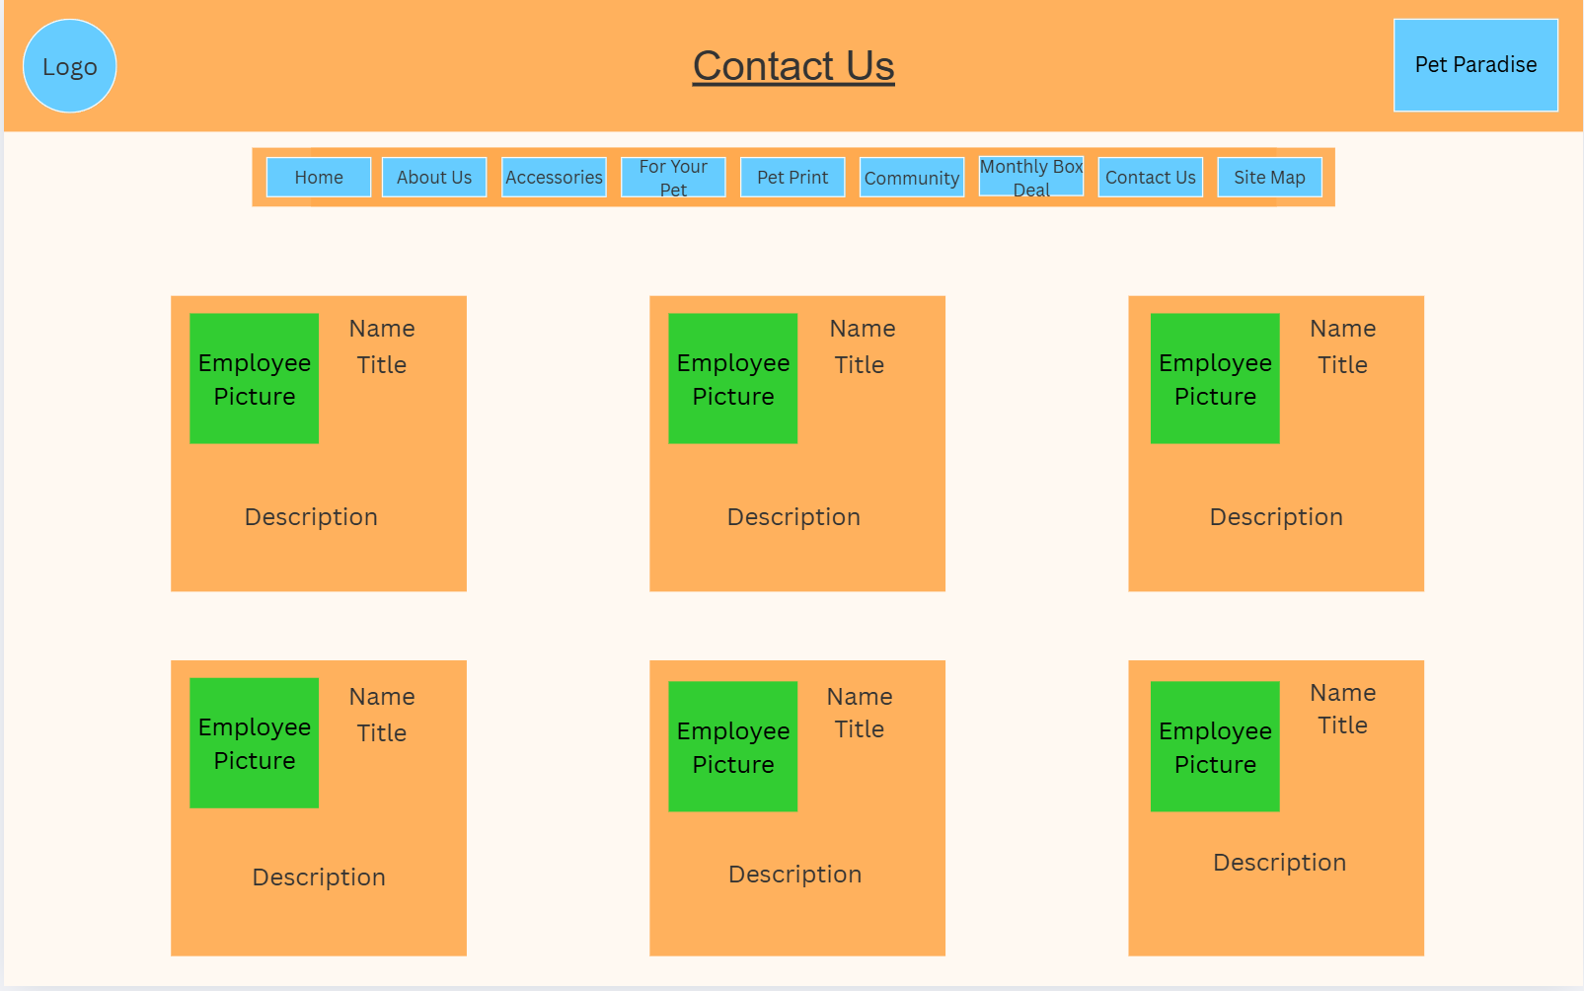

Storyboard Template for Multimedia Product Development
Client Name: Pet Paradise
Project Title: Company Website
Last Update: 10/09/2025 |  | Name of Designer: Kevin Caudell
Panel/Page ID: sitemap.html |  | Panel/Page/Frame No: Site Map
Description of Copy text: | Page Heading: Site Map  Page Heading Style: Font: ‘Arial, Helvetica, sans-serif’, Font Size: 24, Font Color: Dark Grey, Font Decoration: underlined  Sub Header: Site map  Sub Header Style: Font: ‘Arial, Helvetica, sans-serif’, Font Size: 18, Font Color: Vivid Blue, Font Decoration: underlined  Body: Font: ‘Arial, Helvetica, sans-serif’, Font Size: 15, Font Color: Vivid Blue, Font Decoration: underlined
User Interactions: | There is a navigation bar at the top of each webpage on every level of the website. The navigation is always going to be displayed, allowing the customer to navigate to anywhere on the website from any page. The logo at the top left also is a link, linking back to the homepage.  The main body of the webpage has hyperlinks, linking to all levels of the website.
Hyper Links: | index.html  aboutus.html  accessories.html  foryourpet.html  petprint.html  community.html  monthlyboxdeal.html  contactus.html  sitemap.html  customaccessories.html  foryourpetstore.html  petprintstore.html  shareyourpet.html  orderview.html
Audio inclusion and controls: | None
Video inclusion and controls: | None
Color specifications: | Page Background: light orange, fff9f2  Header: (orange, ffa94d, background), (pastel azure, 66ccff, branding name), (light orange, fff9f2, branding name border), (dark grey, 333333, text)  Navigation Bar: (light orange, fff9f2, text borders), (pastel azure, 66ccff, buttons), (green, 32cd32, rollover buttons), (orange, ffa94d, background), (dark grey, 333333, text links).  Body: (vivid blue, 5170ff, hyperlink text)
Panel Layout
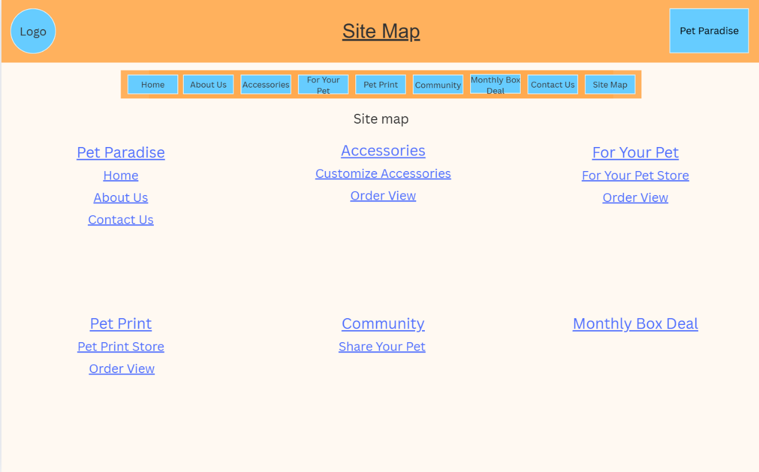

Storyboard Template for Multimedia Product Development
Client Name: Pet Paradise
Project Title: Company Website
Last Update: 10/09/2025 |  | Name of Designer: Kevin Caudell
Panel/Page ID: customaccessories.html |  | Panel/Page/Frame No: Customize Accessories
Description of Copy text: | Page Heading: Customize Accessories  Page Heading Style: Font: ‘Arial, Helvetica, sans-serif’, Font Size: 24, Font Color: Dark Grey, Font Decoration: underlined  Sub Header: Name of chosen Item from Accessories webpage  Sub Header Style: Font: ‘Arial, Helvetica, sans-serif’, Font Size: 18, Font Color: Dark Grey  Body: COLOR, SIZE, MATERIAL.  Body Style: Font: ‘Arial, Helvetica, sans-serif’, Font Size: 14, Font Color: Black, Font Decoration: Upper Case
User Interactions: | There is a navigation bar at the top of each webpage on every level of the website. The navigation is always going to be displayed, allowing the customer to navigate to anywhere on the website from any page. The logo at the top left also is a link, linking back to the homepage.  The button “View Order” links to the next level in the website.
Hyper Links: | index.html  aboutus.html  accessories.html  foryourpet.html  petprint.html  community.html  monthlyboxdeal.html  contactus.html  sitemap.html  orderview.html
Audio inclusion and controls: | None
Video inclusion and controls: | None
Color specifications: | Page Background: light orange, fff9f2  Header: (orange, ffa94d, background), (pastel azure, 66ccff, branding name), (light orange, fff9f2, branding name border), (dark grey, 333333, text)  Navigation Bar: (light orange, fff9f2, text borders), (pastel azure, 66ccff, buttons), (green, 32cd32, rollover buttons), (orange, ffa94d, background), (dark grey, 333333, text links).  Body: (orange, ffa94d, Sub Header Background), (pastel azure, 66ccff, sub headers), (light orange, fff9f2, sub header borders), (dark grey, 333333, text) (green, 32cd32, View Order button).
Panel Layout
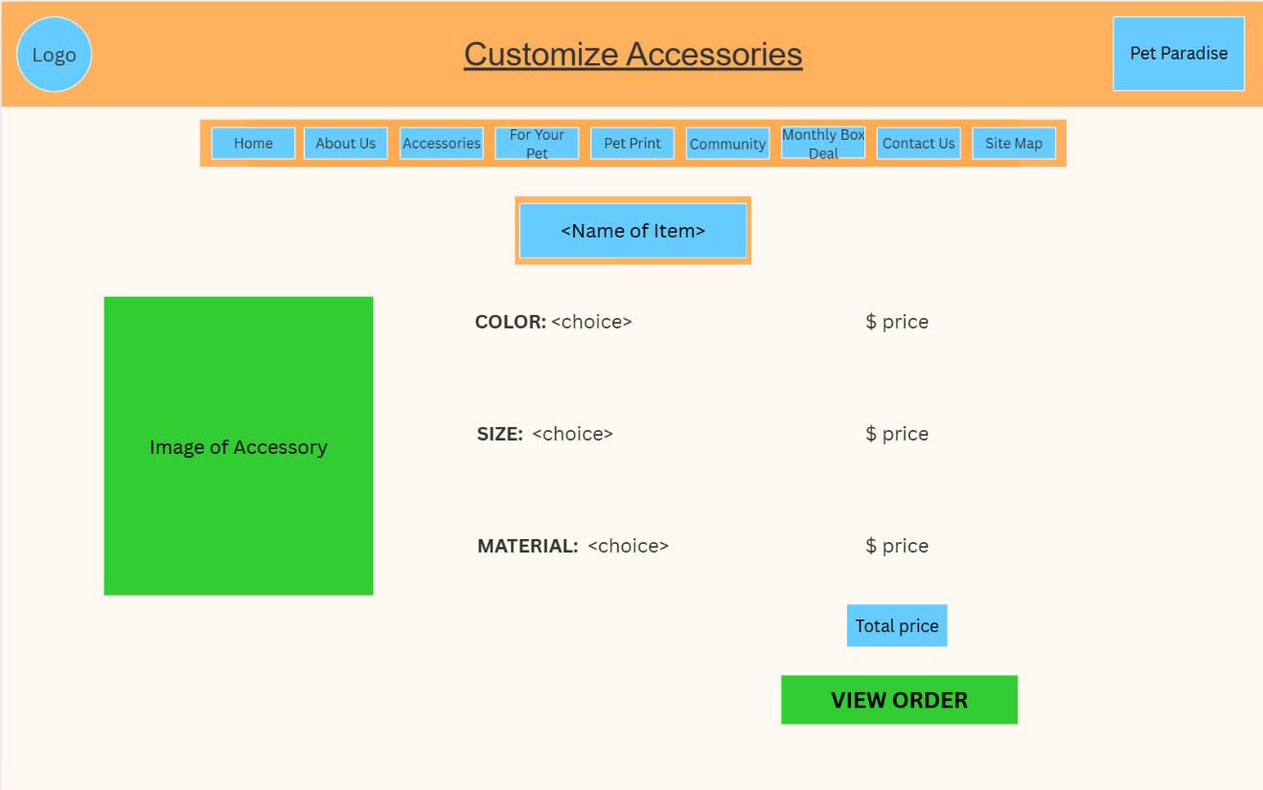

Storyboard Template for Multimedia Product Development
Client Name: Pet Paradise
Project Title: Company Website
Last Update: 10/09/2025 |  | Name of Designer: Kevin Caudell
Panel/Page ID: foryourpetstore.html |  | Panel/Page/Frame No: For Your Pet Store
Description of Copy text: | Page Heading: For Your Pet Store  Page Heading Style: Font: ‘Arial, Helvetica, sans-serif’, Font Size: 24, Font Color: Dark Grey, Font Decoration: underlined  Sub Header: TOYS, FURNITURE  Sub Header Style: Font: ‘Arial, Helvetica, sans-serif’, Font Size: 18, Font Color: Dark Grey , Font Decoration: BOLD, Underline  Body: Price  Body Style: Font: ‘Arial, Helvetica, sans-serif’, Font Size: 14, Font Color: Black  View Order Button: View Order  View Order Button Style: Font: ‘Arial, Helvetica, sans-serif’, Font Size: 15, Font Color: Black, Font Decoration: Upper Case, BOLD
User Interactions: | There is a navigation bar at the top of each webpage on every level of the website. The navigation is always going to be displayed, allowing the customer to navigate to anywhere on the website from any page. The logo at the top left also is a link, linking back to the homepage.  The button “View Order” links to the next level in the website.
Hyper Links: | index.html  aboutus.html  accessories.html  foryourpet.html  petprint.html  community.html  monthlyboxdeal.html  contactus.html  sitemap.html  orderview.html
Audio inclusion and controls: | None
Video inclusion and controls: | None
Color specifications: | Page Background: light orange, fff9f2  Header: (orange, ffa94d, background), (pastel azure, 66ccff, branding name), (light orange, fff9f2, branding name border), (dark grey, 333333, text)  Navigation Bar: (light orange, fff9f2, text borders), (pastel azure, 66ccff, buttons), (green, 32cd32, rollover buttons), (orange, ffa94d, background), (dark grey, 333333, text links).  Body: (orange, ffa94d, sub header background), (pastel azure, 66ccff, sub header), (light orange, fff9f2, sub header borders and image border), (dark grey, 333333, text) (green, 32cd32, View Order button).
Panel Layout
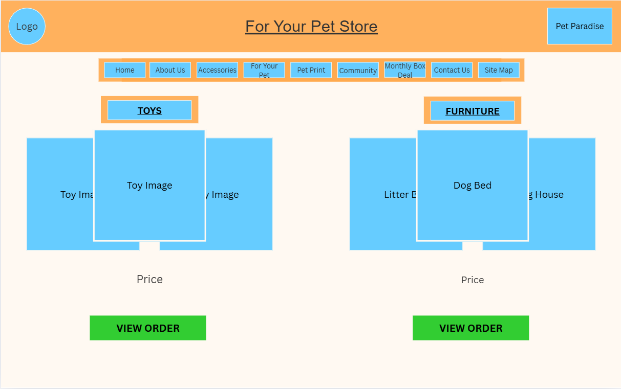

Storyboard Template for Multimedia Product Development
Client Name: Pet Paradise
Project Title: Company Website
Last Update: 10/09/2025 |  | Name of Designer: Kevin Caudell
Panel/Page ID: petprintstore.html |  | Panel/Page/Frame No: Pet Print Store
Description of Copy text: | Page Heading: Pet Print Store  Page Heading Style: Font: ‘Arial, Helvetica, sans-serif’, Font Size: 24, Font Color: Dark Grey, Font Decoration: underlined  Sub Header: Name of Chosen Item from Pet Print webpage  Sub Header Style: Font: ‘Arial, Helvetica, sans-serif’, Font Size: 18, Font Color: Dark Grey  Body: COLOR, SIZE, MATERIAL  Body: Font: ‘Arial, Helvetica, sans-serif’, Font Size: 14, Font Color: Black, Font Decoration: Upper Case  View Order Button: VIEW ORDER  View Order Button Style: Font: ‘Arial, Helvetica, sans-serif’, Font Size: 15, Font Color: Black, Font Decoration: Upper Case, BOLD
User Interactions: | There is a navigation bar at the top of each webpage on every level of the website. The navigation is always going to be displayed, allowing the customer to navigate to anywhere on the website from any page. The logo at the top left also is a link, linking back to the homepage.  The button “View Order” links to the next level in the website.
Hyper Links: | index.html  aboutus.html  accessories.html  foryourpet.html  petprint.html  community.html  monthlyboxdeal.html  contactus.html  sitemap.html  orderview.html
Audio inclusion and controls: | None
Video inclusion and controls: | None
Color specifications: | Page Background: light orange, fff9f2  Header: (orange, ffa94d, background), (pastel azure, 66ccff, branding name), (light orange, fff9f2, branding name border), (dark grey, 333333, text)  Navigation Bar: (light orange, fff9f2, text borders), (pastel azure, 66ccff, buttons), (green, 32cd32, rollover buttons), (orange, ffa94d, background), (dark grey, 333333, text links).  Body: (orange, ffa94d, sub header background), (pastel azure, 66ccff, sub header), (light orange, fff9f2, sub header borders), (dark grey, 333333, text) (green, 32cd32, View Order button), pastel azure, 66ccff, Total price)
Panel Layout
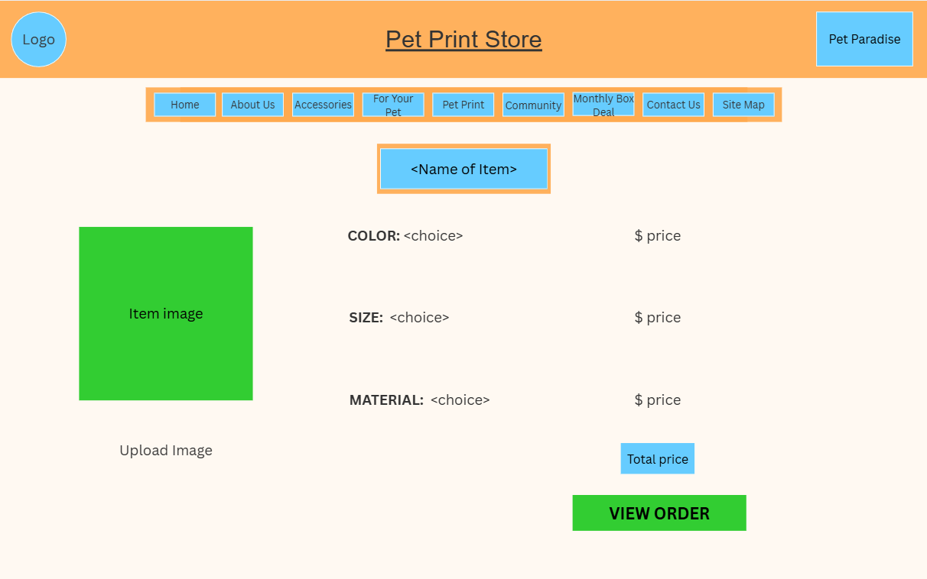

Storyboard Template for Multimedia Product Development
Client Name: Pet Paradise
Project Title: Company Website
Last Update: 10/09/2025 |  | Name of Designer: Kevin Caudell
Panel/Page ID: shareyourpet.html |  | Panel/Page/Frame No: Share Your Pet
Description of Copy text: | Page Heading: Share Your Pet  Page Heading Style: Font: ‘Arial, Helvetica, sans-serif’, Font Size: 24, Font Color: Dark Grey, Font Decoration: underlined  Body: Add Image, Comment, and Comments written by person wanting to post.  Body Style: Font: ‘Arial, Helvetica, sans-serif’, Font Size: 14, Font Color: Dark Grey, Font Decoration: Upper Case  Post Button: Post  Post Button Style: Font: ‘Arial, Helvetica, sans-serif’, Font Size: 14, Font Color: Dark grey
User Interactions: | There is a navigation bar at the top of each webpage on every level of the website. The navigation is always going to be displayed, allowing the customer to navigate to anywhere on the website from any page. The logo at the top left also is a link, linking back to the homepage.
Hyper Links: | index.html  aboutus.html  accessories.html  foryourpet.html  petprint.html  community.html  monthlyboxdeal.html  contactus.html  sitemap.html
Audio inclusion and controls: | None
Video inclusion and controls: | None
Color specifications: | Page Background: light orange, fff9f2  Header: (orange, ffa94d, background), (pastel azure, 66ccff, branding name), (light orange, fff9f2, branding name border), (dark grey, 333333, text)  Navigation Bar: (light orange, fff9f2, text borders), (pastel azure, 66ccff, buttons), (green, 32cd32, rollover buttons), (orange, ffa94d, background), (dark grey, 333333, text links).  Body: (dark grey, 333333, text) (green, 32cd32, Post button).
Panel Layout
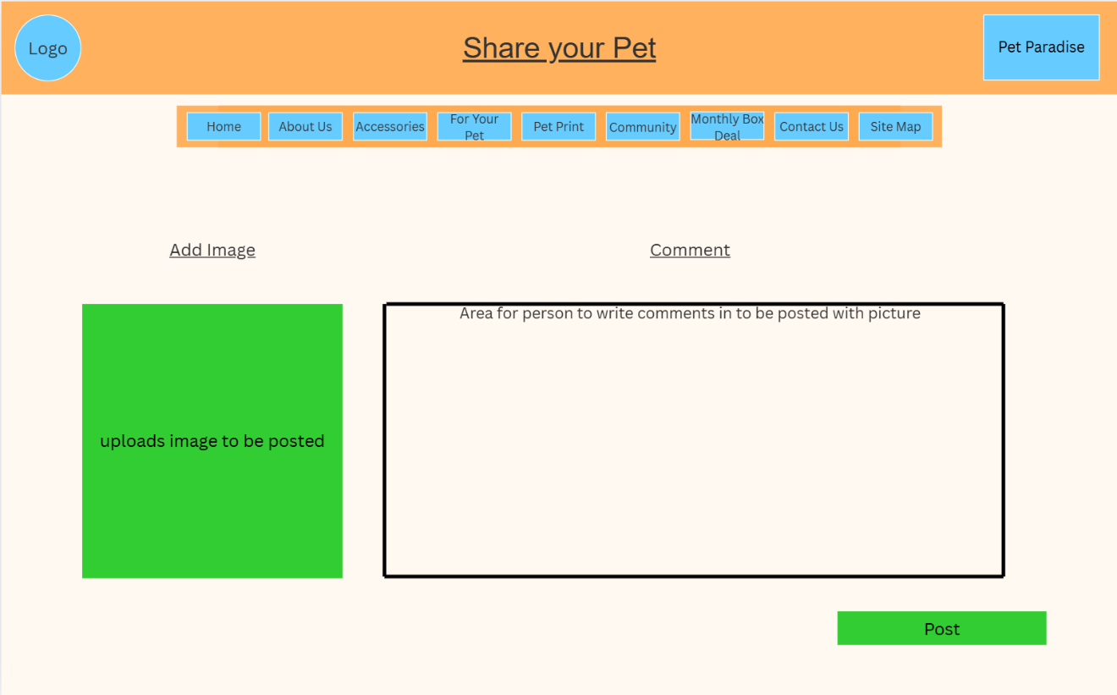

Storyboard Template for Multimedia Product Development
Client Name: Pet Paradise
Project Title: Company Website
Last Update: 10/09/2025 |  | Name of Designer: Kevin Caudell
Panel/Page ID: orderview.html |  | Panel/Page/Frame No: Order View
Description of Copy text: | Page Heading: Order View  Page Heading Style: Font: ‘Arial, Helvetica, sans-serif’, Font Size: 24, Font Color: Dark Grey, Font Decoration: underlined  Sub Header: Item from previous page  Sub Header Style: Font: ‘Arial, Helvetica, sans-serif’, Font Size: 18, Font Color: Dark Grey  Body: COLOR, SIZE, MATERIAL  Body Style: Font: ‘Arial, Helvetica, sans-serif’, Font Size: 14, Font Color: Dark Grey, Font Decoration: Upper Case  Order Now Button: ORDER NOW  Order Now Button Style: Font: ‘Arial, Helvetica, sans-serif’, Font Size: 14, Font Color: Black, Font Decoration: Upper Case
User Interactions: | There is a navigation bar at the top of each webpage on every level of the website. The navigation is always going to be displayed, allowing the customer to navigate to anywhere on the website from any page. The logo at the top left also is a link, linking back to the homepage.
Hyper Links: | index.html  aboutus.html  accessories.html  foryourpet.html  petprint.html  community.html  monthlyboxdeal.html  contactus.html  sitemap.html
Audio inclusion and controls: | None
Video inclusion and controls: | None
Color specifications: | Page Background: light orange, fff9f2  Header: (orange, ffa94d, background), (pastel azure, 66ccff, branding name), (light orange, fff9f2, branding name border), (dark grey, 333333, text)  Navigation Bar: (light orange, fff9f2, text borders), (pastel azure, 66ccff, buttons), (green, 32cd32, rollover buttons), (orange, ffa94d, background), (dark grey, 333333, text links).  Body: (orange, ffa94d, sub header background), (pastel azure, 66ccff, sub headers), (light orange, fff9f2, sub header borders), (dark grey, 333333, text) (green, 32cd32, Order now button), (pastel azure, 66ccff, Total price)
Panel Layout
